Project
BSSE 5-1: Software Design and Construction



Submitted by:
- Shaheer Faisal (53038)
- Abdul Ahad(53936)
- Sudais Malik (53006)
- Mustafa Tahir (56462)
TOPIC :Automated SCADA System for Remote Gas Well Monitoring and Flow Control at OGDCL Remote Sites
USE CASE DIAGRAM:

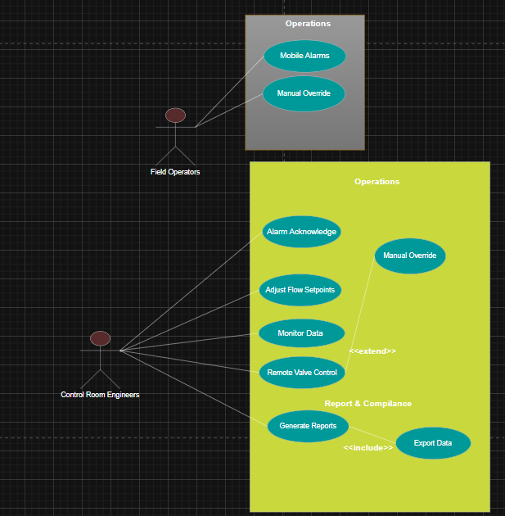
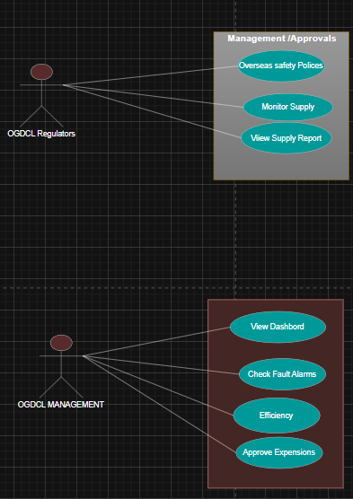
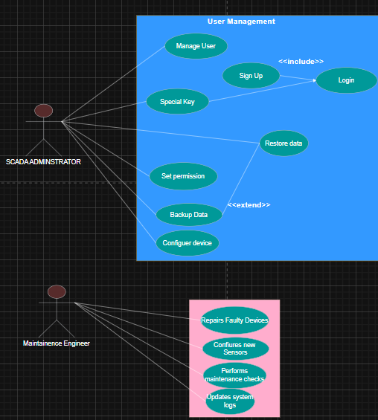
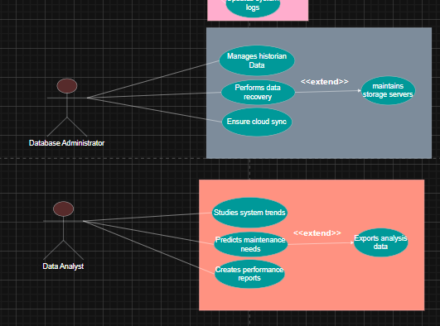

TOPIC :Automated SCADA System for Remote Gas Well Monitoring and Flow Control at OGDCL Remote Sites - Fully Dressed Use Cases (Table Format)

Field Operators :
Use Case No | 1
Use Case name | Monitor and Report Field Data
Actor | Field Operators
Type | Primary
Description | Field operators check data from sensors and report any issue found.
Preconditions | Operator must be logged in and system should be running.
Postconditions | Data is viewed or issue is reported successfully.
MAIN FLOW: | Actor Action | System Response
 | 1. Operator logs into system | System verifies operator login
 | 2. Operator views live data | System shows updated readings
 | 3. Operator reports any issue | System records and sends report

- Alternative Flow / Extension
• A1.1: If data not loading → System shows error message and retries.

Control Room Engineers
Use Case No | 2
Use Case name | Control and Monitor Operations
Actor | Control Room Engineers
Type | Primary
Description | Control room engineers monitor alarms and control the flow of operations.
Preconditions | Engineer must have valid system access.
Postconditions | Operations are adjusted and alarms are handled.
Main Flow: | Actor Action | System Response
 | 1. Engineer checks system dashboard | System displays real-time operations
 | 2. Engineer responds to alarms | System logs the alarm and updates status
 | 3. Engineer adjusts system controls | System applies new settings

- Alternative Flow / Extension
• A2.1: If command fails → System alerts engineer to retry.

OGDCL Regulators
Use Case No | 3
Use Case name | Review Reports and Compliance Data
Actor | OGDCL Regulators
Type | Primary
Description | Regulators review reports to make sure all operations follow company rules.
Preconditions | Regulator must be logged in with read access.
Postconditions | Reports are reviewed or downloaded.
Main Flow: | Actor Action | System Response
 | 1. Regulator logs in | System verifies credentials
 | 2. Regulator selects a report | System shows report details
 | 3. Regulator downloads report | System saves a copy for regulator

- Alternative Flow / Extension
• A3.1: If report missing → System displays a 'not available' message.

OGDCL Management
Use Case No | 4
Use Case name | View Performance Reports
Actor | OGDCL Management
Type | Primary
Description | Management reviews performance data to make business decisions.
Preconditions | Manager must be logged in.
Postconditions | Reports are generated or exported for use.
Main Flow: | Actor Action | System Response
 | 1. Manager opens reporting panel | System shows report options
 | 2. Manager selects time period | System gathers report data
 | 3. Manager views or exports report | System displays or downloads report

- Alternative Flow / Extension
• A4.1: If data not found → System asks to try again later.

SCADA Administrator
Use Case No | 5
Use Case name | Manage Users and System Settings
Actor | SCADA Administrator
Type | Primary
Description | Administrator manages users, settings, and ensures system security.
Preconditions | Admin must have admin rights.
Postconditions | System settings or user details are updated.
Main Flow: | Actor Action | System Response
 | 1. Admin logs into admin panel | System opens control panel
 | 2. Admin adds or removes user | System updates user data
 | 3. Admin changes settings | System saves new configurations

- Alternative Flow / Extension
• A5.1: If setting fails → System shows an error and reverts to old setup.

Maintenance Engineer
Use Case No | 6
Use Case name | Perform and Log Maintenance
Actor | Maintenance Engineer
Type | Primary
Description | Maintenance engineer performs maintenance tasks and logs updates.
Preconditions | Engineer must be logged in.
Postconditions | Maintenance task is saved and marked complete.
Main Flow: | Actor Action | System Response
 | 1. Engineer views scheduled tasks | System lists maintenance items
 | 2. Engineer completes task | System marks task as done
 | 3. Engineer logs comments | System stores maintenance record

- Alternative Flow / Extension
• A6.1: If task delayed → System updates next schedule automatically.

Database Administrator
Use Case No | 7
Use Case name | Backup and Manage Database
Actor | Database Administrator
Type | Primary
Description | Database administrator maintains system data and ensures backups.
Preconditions | DBA must have full access.
Postconditions | Database backup is completed successfully.
Main Flow: | Actor Action | System Response
 | 1. DBA starts backup process | System begins data backup
 | 2. DBA checks data logs | System displays log summary
 | 3. DBA stores backup safely | System confirms backup saved

- Alternative Flow / Extension
• A7.1: If backup fails → System alerts DBA to retry.

Data Analyst
Use Case No | 8
Use Case name | Analyze and Generate Data Insights
Actor | Data Analyst
Type | Primary
Description | Data analyst reviews collected data to find useful information.
Preconditions | Analyst must be logged in.
Postconditions | Analysis results saved or shared.
Main Flow: | Actor Action | System Response
 | 1. Analyst selects dataset | System loads data for review
 | 2. Analyst applies filters | System processes filtered results
 | 3. Analyst saves analysis report | System stores report file

- Alternative Flow / Extension
• A8.1: If data is incomplete → System asks for more input.

SEQUENCE Diagram :
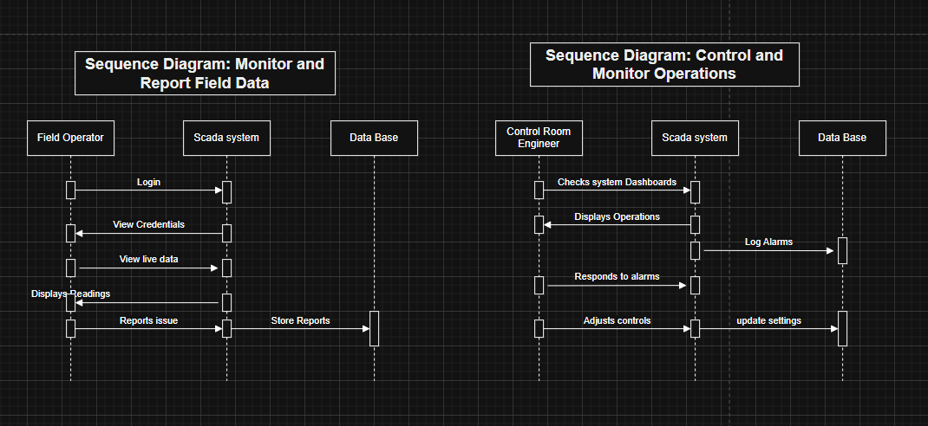
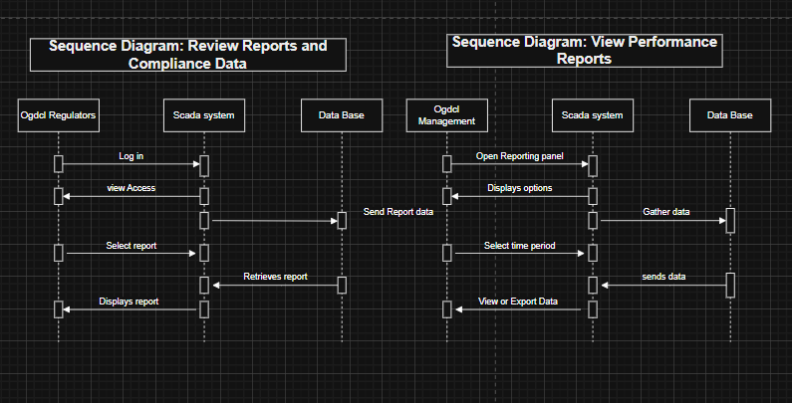

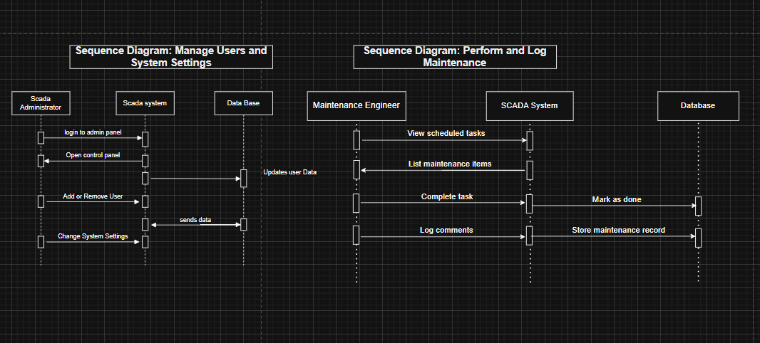
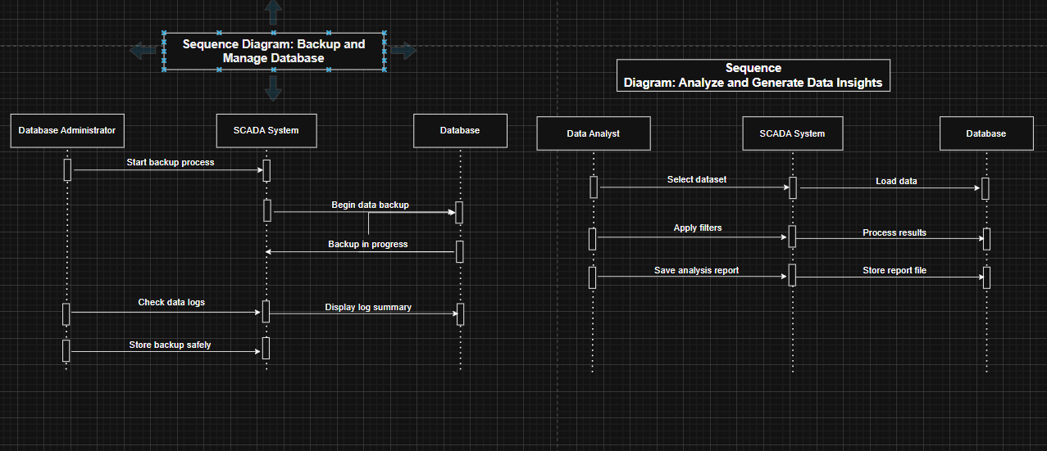

SYSTEM SEQYEUNCE DIAGRAM :
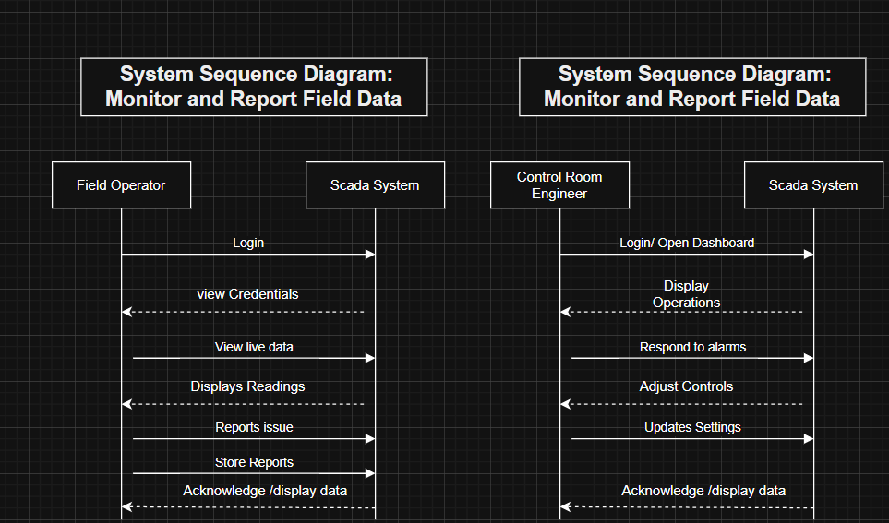
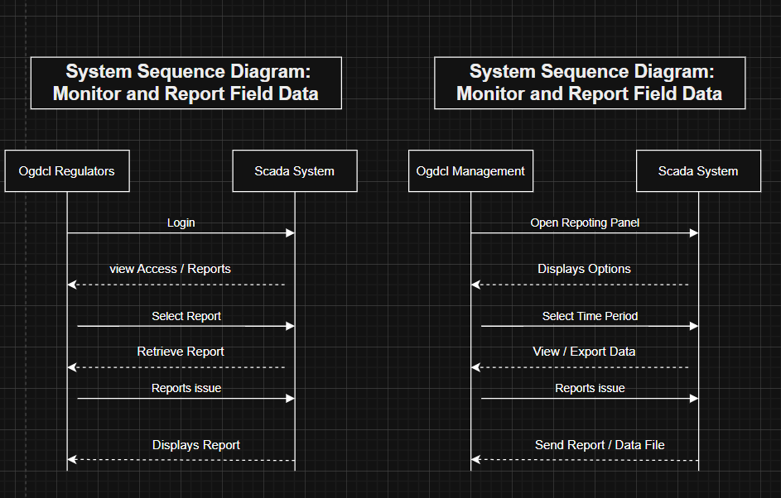

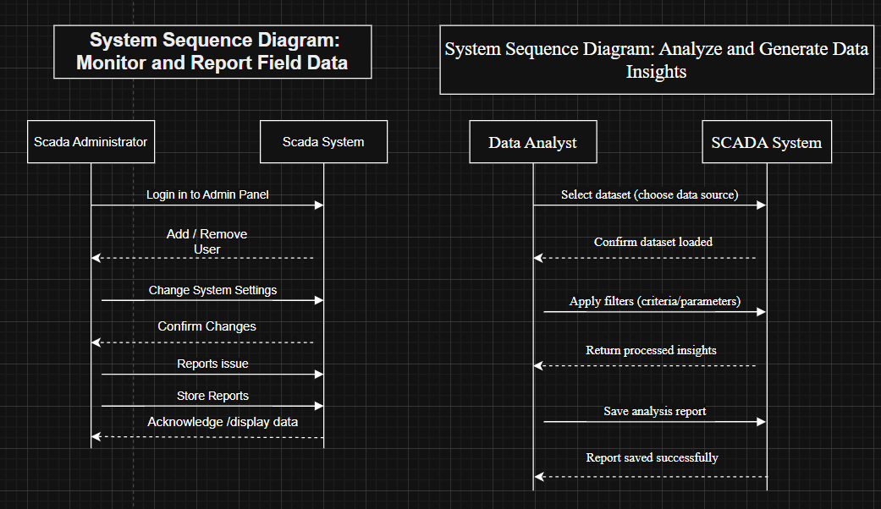
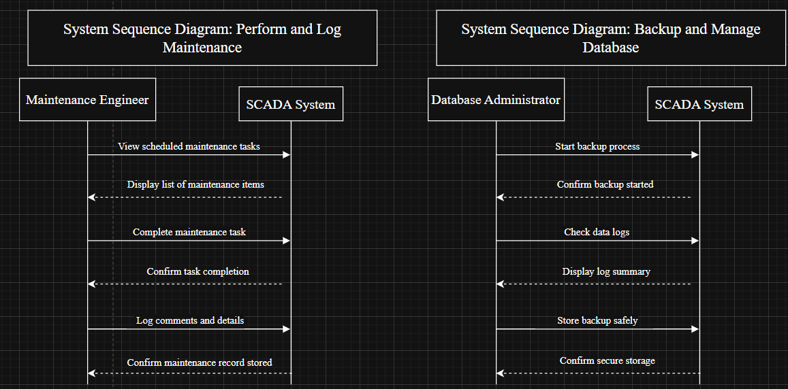

CLASS DIAGRAM :
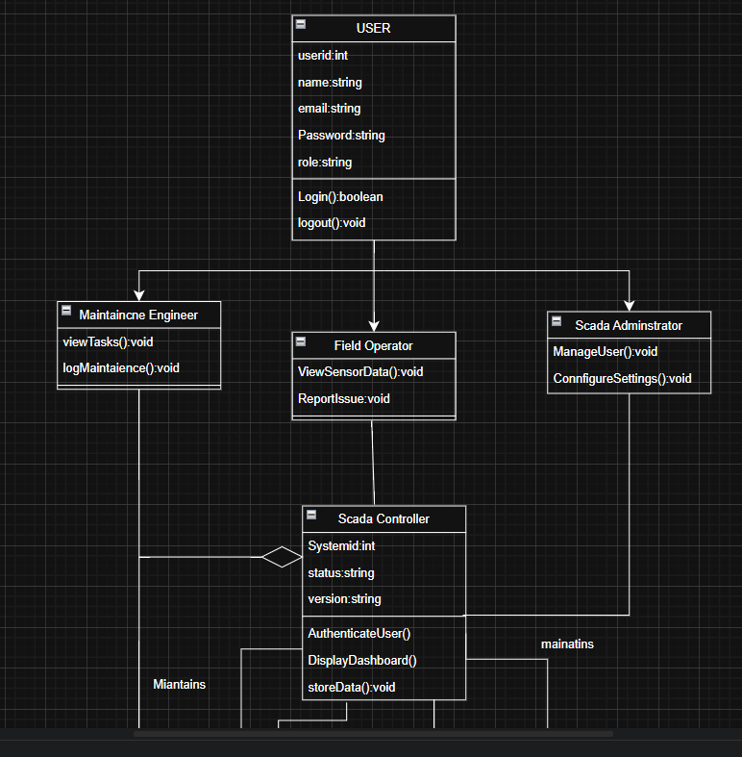
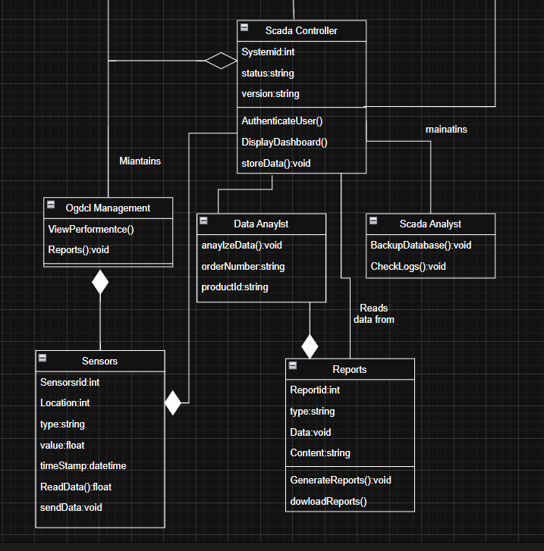

Activity Chart :

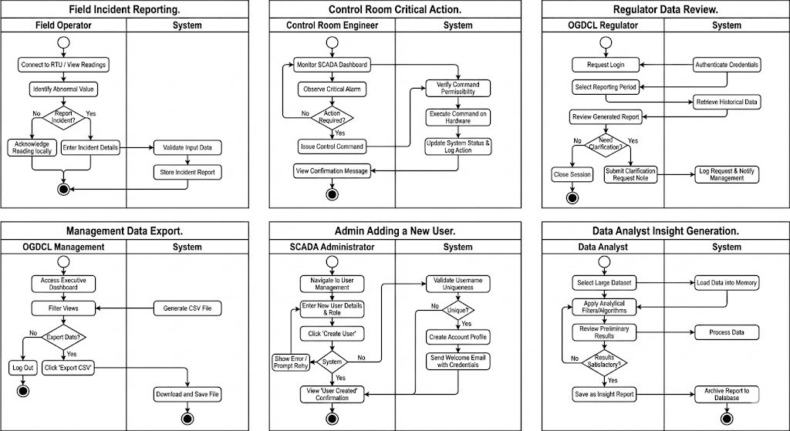
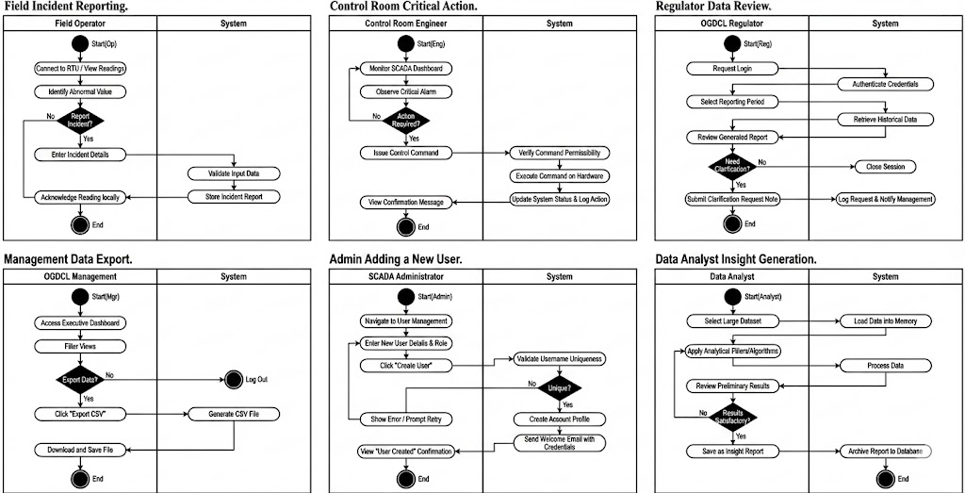

STATE CHART DIAGRAM:
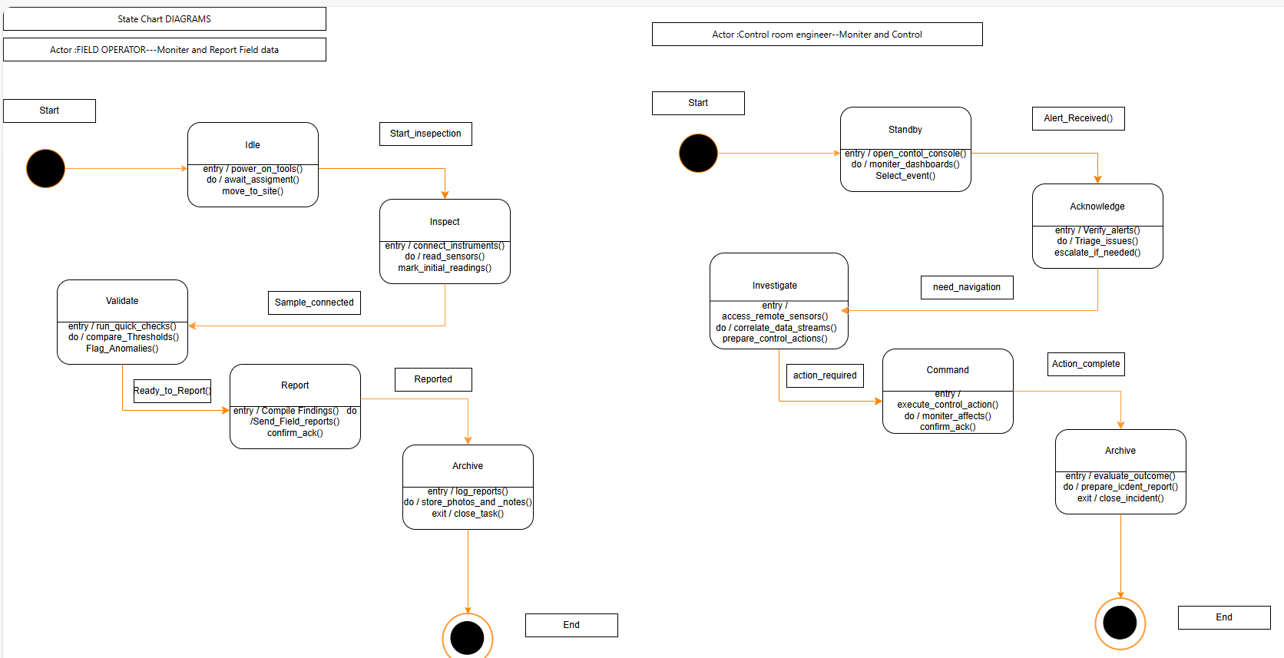
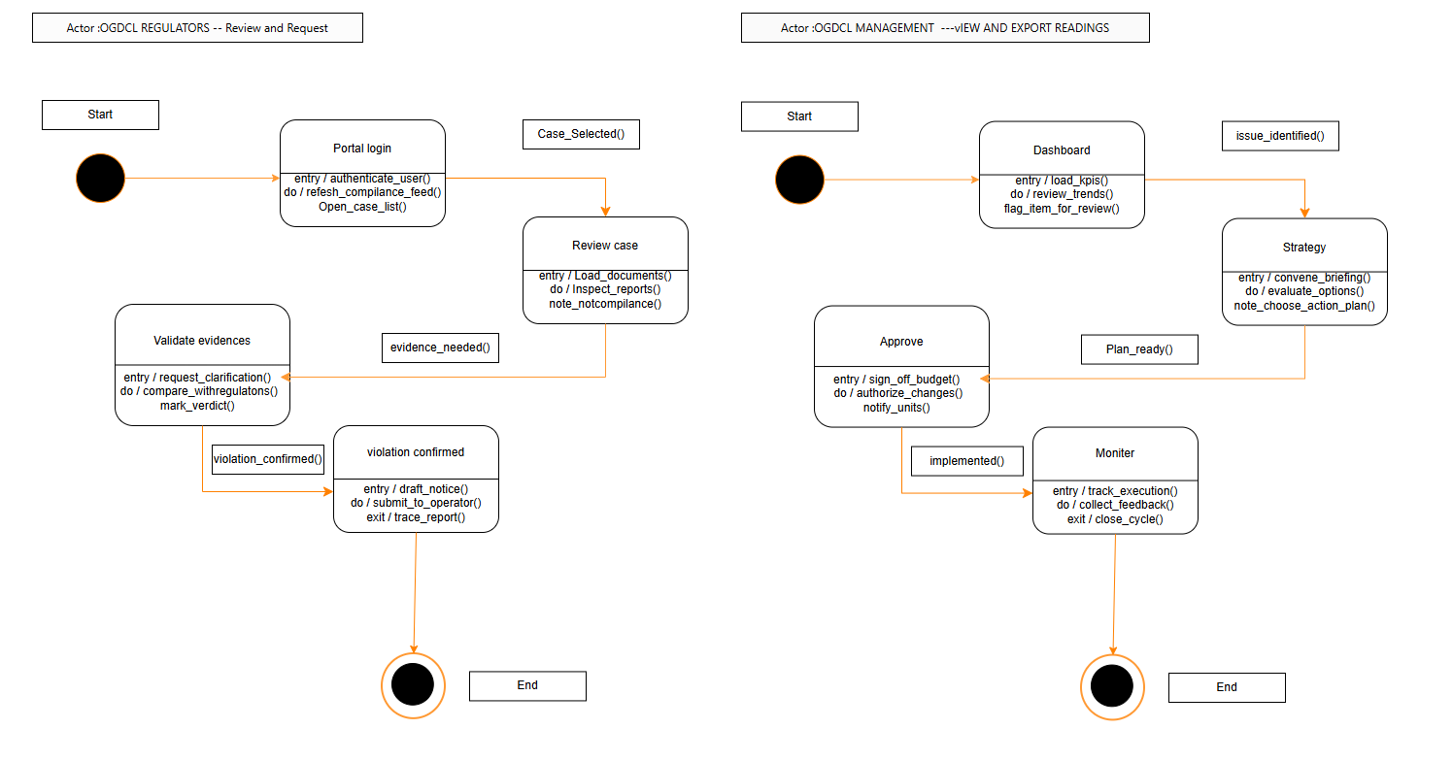

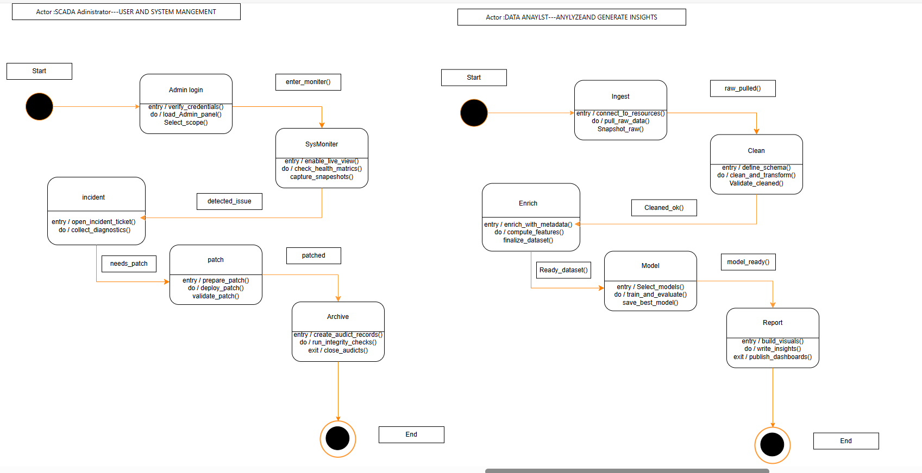
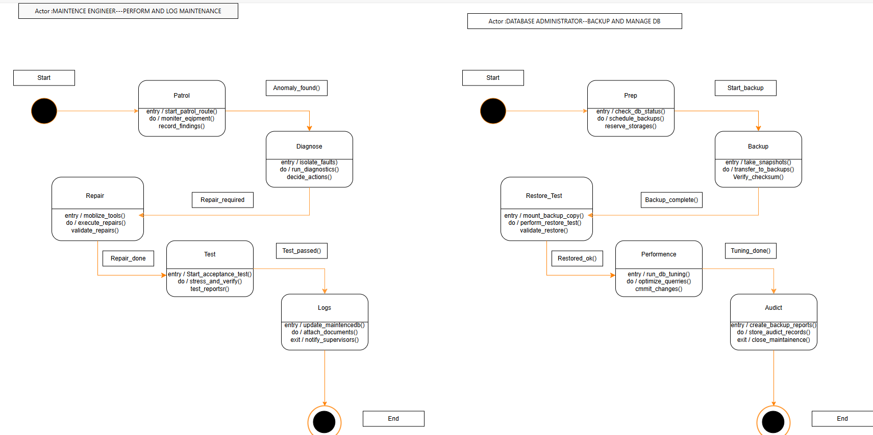

CLASS DIAGRAM CODES
SCADA_SYSTEM :

